**Project 2 Report**

**Experimental Design Analysis: EG390**

**27 April 2021**

**Southern New Hampshire University**

**Manchester, NH**

**Ryan Waterman**

**Table of Contents**

**Objective** 3

**Experimental Model** 4

**Uncertainty Analysis** 5

**Measurement Data** 6

**Data Summary** 8

**Expectations and Findings** 17

**Reflection** 18

**References** 19

**Code, Analysis, and Datasheets** 20

# **Objective**

The objective of this project was to study the uncertainty within a light intensity measurement circuit (LIMC). The uncertainty analysis was completed using several computational methods using data directly output from the sensors within the circuit. Multiple uncertainty analysis methods allow cross examination of the uncertainty within the system and act as an inherent verification of the experimental model.

# **Experimental Model**

The experimental model for the LIMC is comprised of three main components for which an uncertainty analysis can be conducted. These components are a 10k potentiometer, a green LED light, and a photoresistor. An important note is that all components of this circuit are being powered by an Arduino board, which also interprets and records the data from each sensor. For the sake of simplicity in the experimental model, the uncertainty of the Arduino board is assumed to be zero. When experimental data is collected, the uncertainty in the circuit from the Arduino board will be inherently measured and determined to be either significant or negligible. With that being considered, a mathematical model was created to run a preliminary uncertainty analysis with the manufacturer stated uncertainties for each component. For simplicity, the light intensity is defined as $LI$. The formula used in this computation is stated below:

$U_{LI}=U_{pot}+U_{LED}+U_{resist}$ (1)

This equation states that the uncertainty in the measured light intensity value is the sum of the uncertainties in the potentiometer, the LED output, and the photoresistor, respectively. This equation can then be adapted into a Taylor Series Model (TSM) of uncertainty, seen below:

$\left(\frac{U_{{LI}_{measured}}}{{LI}_{measured}}\right)= \sqrt{{\left(\frac{U_{pot}}{pot}\right)}^{2}+ {\left(\frac{U_{LED}}{LED}\right)}^{2}+ {\left(\frac{U_{resist}}{resist}\right)}^{2} }$ (2)

The TSM model of uncertainty analysis is an analytical analysis that is effective when the uncertainty of each measurement relative to the expected value is known. For a more complex computation, a Monte Carlo Simulation (MCS) can be conducted in a program such as MATLAB. The equation used in an MCS is stated below:

$Uncertainty Percentage=\frac{\left(2*σ\left(n\right)\right)}{nominal}$ (3)

The MCS is an iterative process that inputs random numbers for each variable upon each iteration, with the upper and lower bounds of the random numbers being determined by the standard deviation. For example, a nominal light intensity measurement of 200 with a standard deviation (σ) of 7.5 would have a lower bound of 192.5 and an upper bound of 207.5 for the range in which a random number is selected. This process is completed for each variable and iterated “n” times. Returning to equation 3, it is evident that the uncertainty percentage is 2 times the converged standard deviation for n samples, divided by the nominal output for the system.

# **Uncertainty Analysis**

The uncertainty analysis for the LIMC was completed using information from the datasheet of each of the respective circuit components. The results of the TSM uncertainty analysis are stated below:

$\left(\frac{U_{{LI}_{measured}}}{{LI}_{measured}}\right)= 21.21\%$ (4)

An uncertainty of 21.21% in a system with 3 components, each measuring a single variable, is undesirable. This uncertainty percentage is a reflection of the aggregate sensor accuracy; therefore, an acceptable uncertainty percentage is typically under 15%, otherwise the system would not output data that was meaningful in most applications. The results of the MCS are stated below:

$Uncertainty Percentage=23.21\%$ (5)

The results of both the TSM and MCS uncertainty analyses for the LIMC describe a system uncertainty of about 22%. The difference between the two uncertainty analyses, although small, is a result of the complexities of the respective analyses. The TSM can be thought of as a “static” analysis, in which the result of the analysis will always be the same for an unchanging system. This implies that the TSM is simplistic, yet reliable, and generally a good estimate for uncertainty in a static system. The MCS, however, is a much more complex analysis. Due to the nature of the MCS, the result will be different every time, especially when iterating 500 times, as done for this model. Therefore, the MCS can be understood as a “dynamic” model, capable of producing results for much more complex systems than the TSM.

# **Measurement Data**

The method for collecting measurement data in the LIMC was through an Arduino Mega 2560. The code used for data acquisition can be seen below:

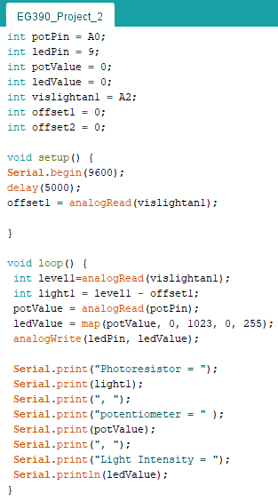

Figure 1: Arduino Data Acquisition Code

The key components of this code are the offset and the map function. The offset subtracts the ambient light level from the data output of the photoresistor after the LED is turned on. This ensures that when the LED is off, the photoresistor output is read as 0. The map function is also critical because it translates the potentiometer input into an analog output on the LED pin, which linearly scales the light intensity with the change in the potentiometer input. This produces zero uncertainty between the potentiometer input and the LED analog output, as a means of eliminating uncertainty that is not accounted for in the TSM and MCS.

The circuit, including each component of the system, can be seen in the image below:

Figure 2: Circuit for Data Acquisition

The notable feature in this circuit the resistor array, indicated by the arrow in the image. This resistor array is comprised of four resistors in series, which have a total resistance of 35 kilo-ohms. One leg of the resistor array is connected to ground, while the other leg is connected between the signal leg of the photoresistor and the yellow signal wire. This configuration of resistors, connected between the signal and ground, is a pull-down resistor. A resistor array was required in this setting to increase the photoresistor’s sensitivity at higher light intensities. This provides greater resolution at the expected light intensity from the LED.

# **Data Summary**

When collecting and analyzing data, a few glaring issues arose each stemming from the potentiometer and the linearity between the LED intensity and the photoresistor output. A band of potentiometer data can be seen below:

Figure 3: Potentiometer Data Distribution at a Fixed Potentiometer Position

As seen in Figure 3, there is a large amount of error in the potentiometer output for a fixed potentiometer position. This position was located approximately halfway between the maximum and minimum positions. To further analyze and understand the uncertainty in this component, the data was sorted from the minimum to the maximum value and then plotted once more, seen below:

Figure 4: Sorted Potentiometer Data Set

Sorting of this data set clearly illustrates the deviation of values from the average. The linear trendline assigned to this plot fit with an R-squared value of 0.8472, which is reasonable considering the lower and upper values for the data set. The information from this data set can be used to derive an experimental uncertainty percentage for the potentiometer at a position between the maximum and minimum, seen below:

$$Maximum=570$$

$$Minimum=464$$

$$Average=516.61$$

$Upper Bound Deviation from Average (UBD)=Maximum-Average=53.39$ (6)

$Lower Bound Deviation from Average (LBD)=Average-Minimum=52.61$ (7)

$U_{{pot}_{experimental}}=\left(\frac{UBD}{Average}\right)+\left(\frac{LBD}{Average}\right)=20.52\%$ (8)

The experimental uncertainty for the potentiometer was determined to be 20.52% at a position halfway between the maximum and minimum position. This value is supported by the datasheet for the potentiometer, which states a tolerance of ±10% for the position.

When continuing forward with data collection, the potentiometer was set to the maximum position. The purpose of this project was to analyze the uncertainty in the system, which would not be possible without a stable potentiometer input. The LED output, as described previously, is mapped directly from the potentiometer input to the Arduino in a 1:1 ratio. Should the potentiometer position not be at a stable maximum value, the LED output would inherit the uncertainty of the potentiometer, which is not an accurate reflection of the uncertainty in the LED itself. Continuing, the photoresistor would then be measuring the LED output, further increasing the system uncertainty as a result of compounding the initial potentiometer uncertainty. A better reflection of the system uncertainty would be measured from a stable potentiometer input value.

Another key issue that is addressed by using the maximum potentiometer position is the non-linearity between the LED output intensity and the photoresistor output. Such non-linearity makes evaluating the uncertainty in the photoresistor very difficult without experimentally developing an equation for the relationship between the LED output data set and the photoresistor output data set. This could be done over several trials utilizing a linear regression, but that is not within the scope of this project. The figure below illustrates the relationship between the LED and photoresistor outputs:

Figure 5: Photoresistor Output vs. Light Intensity

The trendline assigned to this data set is a second order polynomial, and the associated R-squared value is 0.93, indicating a relatively good fitment. Interpreting the data at a fixed light intensity value is a much more accurate method of determining the uncertainty in the photoresistor. A fixed light intensity produces a linear relationship between the relative photoresistor and light intensity measurements.

Given the constraints in the data collection noted above, a series of tests were conducted. The results of the test can be seen in the figures below:

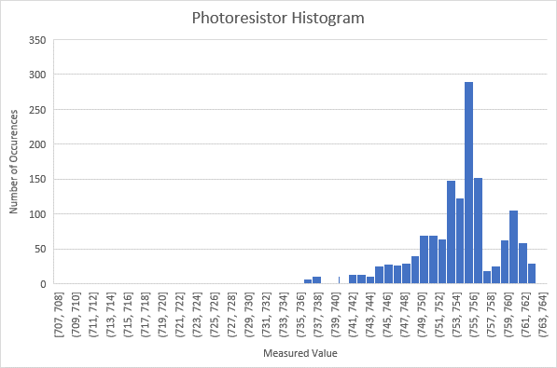

Figure 6: Photoresistor Data Histogram

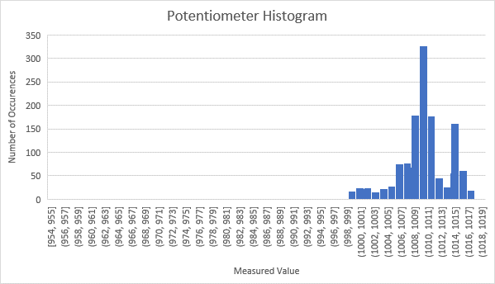

Figure 7: Potentiometer Data Histogram

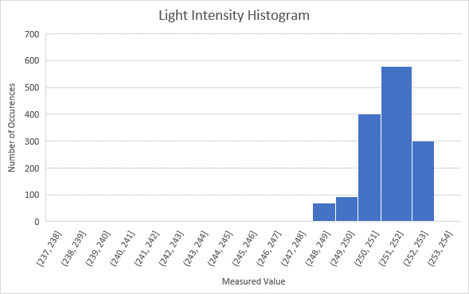

Figure 8: Light Intensity Histogram

The data collected through these trials is best expressed as a histogram, as seen in Figures 6, 7, and 8, above. A histogram is a simple illustration of the number of times a value was measured. This test required a high sampling rate because of the sensitivity and response time of the photoresistor. Due to this high sampling rate, large quantities of data were collected within the approximately one-minute trial duration. This makes a stem and leaf plot unfeasible for representing the data, as the table would have over 500 columns. An important note is that the histogram bin size was reduced to 1 in Figures 6 through 8, therefore the data is represented in a very high resolution. The data distribution is very clear in each of the figures above, which is to be expected with the uncertainties of the sensors.

To analyze the experimental uncertainty of the photoresistor, the measured photoresistor values were plotted against the light intensity value, seen below:

Figure 9: Photoresistor Output vs. Light Intensity

Using the equation of the associated trendline, an expected value for the photoresistor output at a given light intensity value can be determined.

$Expected Photoresistor Output (P_{{out}_{expected}})=\left(3.8313*\left(Light Intensity\right)\right)-209.44$ (9)

$Standard Deviation of P_{{out}_{measured}} (σ_{meas})= \sqrt{\frac{\sum_{i=1}^{n}{{\left(P_{{out}_{measured}}\right)}_{i}^{2}-{\frac{\left(\sum_{i=1}^{n}{{{(P}_{{out}_{measured}})}_{i}}\right)}{n}}^{2}}}{n-1}}$ (10)

$U_{P_{{out}_{measured}}}=\left(\frac{2*σ_{meas}}{Average\left(P_{{out}_{expected}}\right)}\right)=\left(\frac{2*\left(6.4645\right)}{753.961}\right)*100= 1.71\%$ (11)

Applying Equations 9, 10, and 11 to the collected data, the uncertainty in the photoresistor was determined to be 1.71%, which is remarkably low.

A predictive model for the photoresistor output at a given potentiometer input can also be derived using the same method from Figure 9 and Equation 9. A plot of these data sets can be seen below:

Figure 10: Photoresistor Output Measurement vs. Potentiometer Input

Based on the R-squared value of 0.9297 for the second order polynomial trendline, there is a high degree of confidence in the trendline equation as a representation of the data distribution. The equation, located below, can be used as a predictive model of the system behavior:

$\left(P_{{out}_{expected}}\right)=\left(-0.0006*{\left({Pot}_{in}\right)}^{2}\right)+1.0197*\left({Pot}_{in}\right)+49.042$ (12)

Equation 12 can be used to model a predictive curve for the photoresistor output along the same potentiometer data set used in Figure 10. That plot is found in Figure 11, below:

Figure 11: Predicted Photoresistor Output vs. Potentiometer Input

An application for the information provided by Figure 11 is an uncertainty analysis along the entire output range of the potentiometer, not just the stabilized range used for the analysis in this experiment. If this predictive mathematical model could be verified under iterative test conditions, the standard deviation of the measured photoresistor data from the predicted value at a given potentiometer input would indicate the uncertainty in the system. However, such rigorous and time-consuming testing for verification of the predictive mathematical model is outside of the scope of this project. Continuing forward, the system uncertainty for the stable data set can be calculated.

Upon analyzing the potentiometer and LED light intensity uncertainties, the following results were derived:

$U_{pot}=\left(\frac{2*σ_{pot}}{Average\left(pot\right)}\right)=\left(\frac{2*\left(5.9613\right)}{1010.04}\right)*100= 1.18\%$ (13)

$U_{LI}=\left(\frac{2*σ_{LI}}{Average\left(LI\right)}\right)=\left(\frac{2*\left(1.542\right)}{251.455}\right)*100= 1.23\%$ (14)

Both the potentiometer and the LED light intensity uncertainties are very low, which was to be expected. The similarity between the two uncertainties is a result of the previously explained mapping method, and, more specifically, the reduction in resolution of the LED light intensity values. To correctly assess the system uncertainty, the light intensity and potentiometer uncertainties can be averaged. The light intensity is a value derived from the potentiometer value; therefore, the uncertainty is a result of the potentiometer alone. For the sake of thoroughness, however, an averaged uncertainty value will be used. Given the uncertainties of each component, the experimental system uncertainty can be computed using the TSM, found below:

Uncertainty with experimentally measured $U_{pot}$:

$U_{LIMC}=\sqrt{{(U_{pot})}^{2}+{{(U}_{LI})}^{2}+{{(U}_{resist})}^{2}}=\sqrt{{(.2052)}^{2}+{(.0123)}^{2}+{(.0171)}^{2}}=20.63\%$ (15)

Uncertainty without the averaged $U_{pot}$ and $U_{LI}$ in stable system:

$U_{LIMC}=\sqrt{{(U_{pot})}^{2}+{{(U}_{LI})}^{2}+{{(U}_{resist})}^{2}}=\sqrt{{(.0118)}^{2}+{(.0123)}^{2}+{(.0171)}^{2}}=2.41\%$ (16)

Uncertainty with the averaged $U_{pot}$ and $U_{LI}$ in stable system:

$U_{LIMC}=\sqrt{{(U_{{pot}_{avg}})}^{2}+{{(U}_{resist})}^{2}}=\sqrt{{(.0121)}^{2}+{(.0171)}^{2}} = 2.09\%$ (17)

As calculated above, the uncertainty in the LIMC is 2.09% after all corrections were made.

# **Expectations and Findings**

The measured uncertainty in the LIMC proved to be better than expected after adjusting for the instability in the potentiometer. To that point, the potentiometer was experimentally proven to have the same uncertainty as listed in the datasheet. The TSM and MCS analyses were conducted using the uncertainties listed on each sensor datasheet, so the lower system uncertainty during the corrected experiment was expected. A system uncertainty of 2.09%, however, is very impressive. This is a reduction by an order of magnitude from the originally computed uncertainty percentage. Should the analysis that was completed during this project be implemented in the uncorrected system, it is reasonable to assume the experimental uncertainty would match that of the initial TSM and MCS computations. This indicates that the mathematical model of this system is accurate, and there are no other sources of uncertainty that were not accounted for.

# **Reflection**

Upon completing an in-depth analysis into a relatively simplistic system, there are a few meaningful conclusions to be drawn. First, the TSM and MCS methods of uncertainty analysis proved to be accurate within 10% of the experimentally computed system uncertainty, verifying the efficacy of such analysis methods. Second, it was interesting to see that there could still be meaningful conclusions drawn from seemingly erroneous data. Initially, the fluctuations in the potentiometer input were very concerning and difficult to explain. However, upon completing thorough analysis of the potentiometer data, it became evident that it was behaving exactly as described by the manufacturer. Finally, a deep, intuitive understanding of statistical analysis was developed throughout this project. Prior to the experimentation, a surface level understanding of standard deviation, uncertainty, and statistical analysis were sufficient. After conducting the experiment, the intrinsic definition of the statistical methods and how they relate was understood.

# **References**

Montgomery, Douglas C., et al. *Engineering Statistics*. John Wiley & Sons, Inc., 2011.

# **Code, Analysis, and Datasheets**

MCS Code:

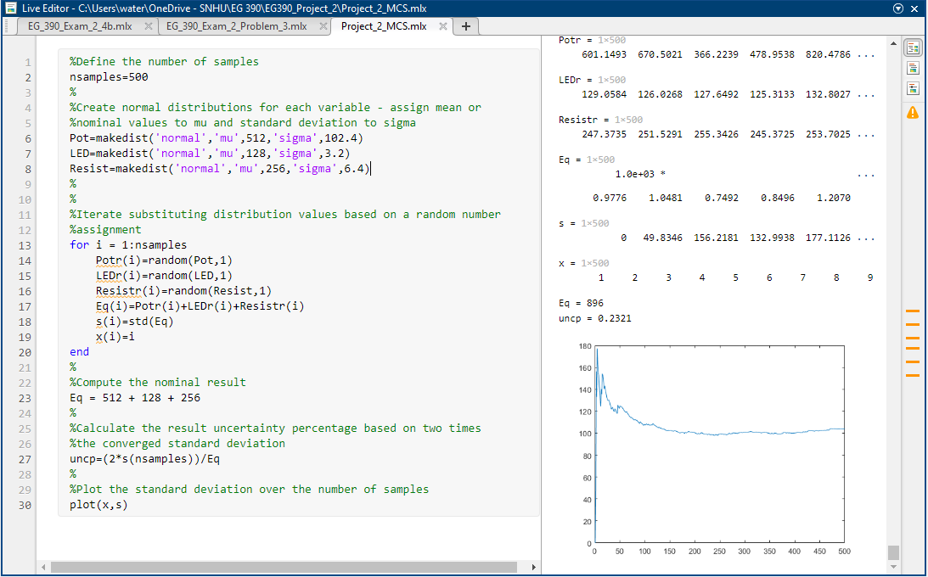

TSM Derivation:

$$\left(\frac{U_{{LI}_{measured}}}{{LI}_{measured}}\right)= \sqrt{{\left(\frac{U_{pot}}{pot}\right)}^{2}+ {\left(\frac{U_{LED}}{LED}\right)}^{2}+ {\left(\frac{U_{resist}}{resist}\right)}^{2} }=\sqrt{{\left(0.2\right)}^{2}+ {\left(0.05\right)}^{2}+ {\left(0.05\right)}^{2} }=21.21\%$$

Potentiometer Datasheet:

<https://www.piher.net/piher-nacesa.com/pdf/14-PT15v03.pdf>

LED Datasheet:

<https://www.sunledusa.com/products/spec/XLVG11D5V.pdf>

Photoresistor Datasheet:

<https://media.digikey.com/pdf/Data%20Sheets/Photonic%20Detetectors%20Inc%20PDFs/PDV-P8001.pdf>

10K Resistor Datasheet:

<https://www.te.com/commerce/DocumentDelivery/DDEController?Action=srchrtrv&DocNm=1773265&DocType=DS&DocLang=English>